Practical No: 04

**Aim:** Controlling Raspberry Pi with Telegram.

**Hardware Required:**

1. Raspberry Pi 3B+
2. Ethernet Cable
3. Monitor
4. HDMI to VGA convertor
5. Micro SD card (any class best is class 10)
6. Adaptor with 5v 2A
7. USB mouse
8. USB keyboard
9. Relay board
10. Female – male jumper wires.
11. Bread Board

**Software Required:**

1. Raspbian OS
2. Geany Programmer’s Editor
3. Telegram App

**Procedure:**

1. **Hardware Setup:**

* Connect according to the figure.

GPIO20 🡪 LED2 Anode

GPIO21 🡪 LED3 Anode

*Black wire is the GND (ground)

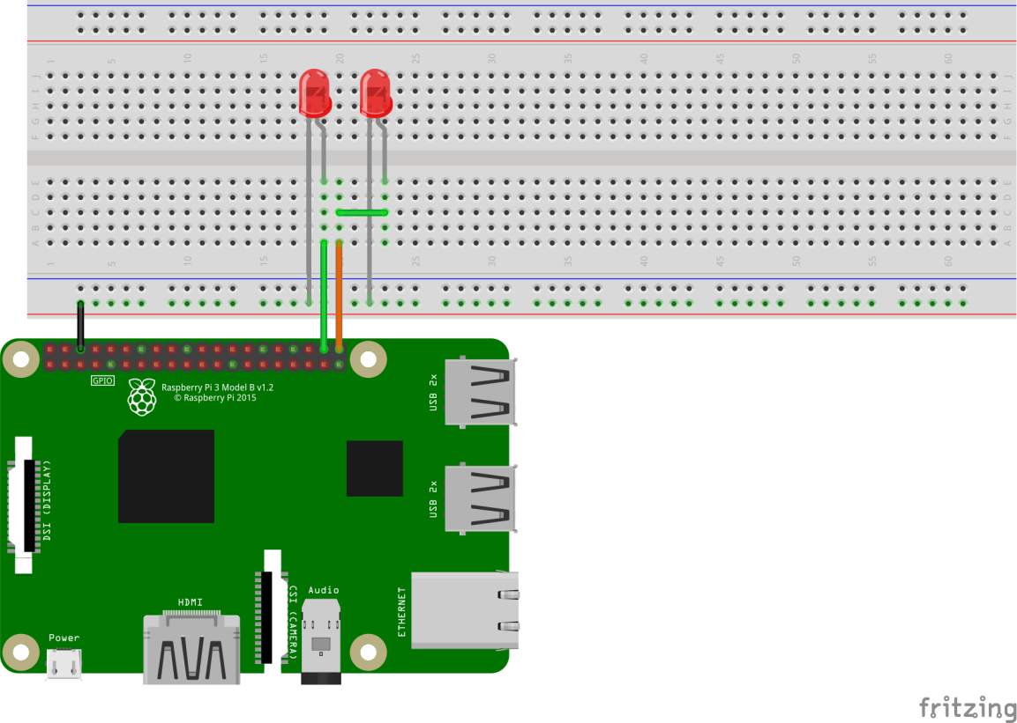

1. **Software Setup:**

* Install Telegram in android phone.
* Search for contact “BotFather”
* Send him “/start” command
* Send him “/newbot”
* Give a name to you bot
* Give a username to the bot (It must be a unique one)
* On success you will be provided with a HTTP API token. (jot it down)
* In Raspberry Pi Terminal type the following…
  + sudo apt update
  + sudo apt upgrade
  + sudo pip install telepot
* open Geany Programmer’s Editor and create a python script as given below

*import sys*

*import time*

*import random*

*import datetime*

*import telepot*

*from gpiozero import LED*

*led1=LED(21)*

*led2=LED(20)*

*def onled1():*

*led1.on()*

*return*

*def offled1():*

*led1.off()*

*return*

*def onled2():*

*led2.on()*

*return*

*def offled2():*

*led2.off()*

*return*

*def handle(msg):*

*chat_id = msg['chat']['id']*

*command = msg['text']*

*print 'Got command: %s' % command*

*if command == 'on led1':*

*bot.sendMessage(chat_id, onled1())*

*elif command =='off led1':*

*bot.sendMessage(chat_id, offled1())*

*elif command =='on led2':*

*bot.sendMessage(chat_id, onled2())*

*elif command =='off led2':*

*bot.sendMessage(chat_id, offled2())*

*bot = telepot.Bot('****YourToken****’) (enter the jotted token)*

*bot.message_loop(handle)*

*print 'I am listening...'*

*while 1:*

*time.sleep(10)*

*led1.off()*

*led2.off()*

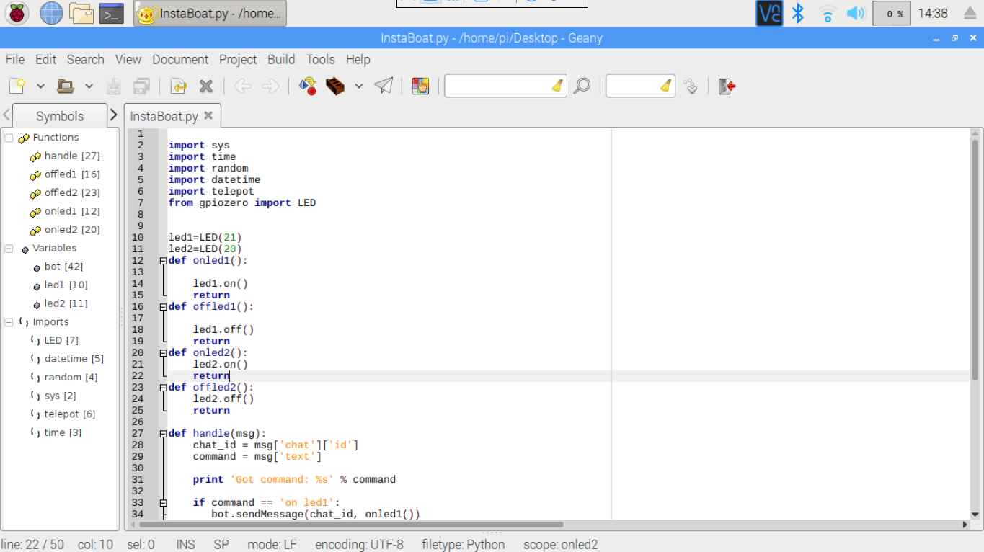

* Run the program by clicking on the rocket Icon.

**Precautions:**

* If it is a fresh flash of Rasbian OS “*sudo apt update”* and “*sudo apt upgrade”* is a must thing.
* Connect the components before powering on the device and double check your connections.
* Take the help of the professor in connection as this project includes use of high voltage.

**Conclusion:**

* We are able to control two LED lights through Telegram app.
* By sending “on led1” switches on the led1 and “off led1” switches off led1, and vise-versa